ORgSys

(Organization Recognition System)

Design Classes

Class Diagram

Submitted to:

Asst. Prof. Ma. Rowena C. Solamo

Faculty Member

Department of Computer Science

College of Engineering

University of the Philippines, Diliman

Submitted by:

GRANADA, Patrick James B.

MERCADO, Emir R.

YAP, Sharmaine A.

In partial fulfillment of Academic Requirements

Revision Control

*History Revision:*

| Revision Date | Person Responsible | Version  Number | Modification |
| --- | --- | --- | --- |
| 10/20/2013 | Sharmaine Yap  Emir Mercado | 1.0 | Initial Document |
|  |  |  |  |

*System Name*: ORgSys (Organization Recognition System)

*Description*: The system's purpose is primarily to provide the Office of Student Affairs of UP Diliman's College of Engineering a means of evaluating the organizations during their application period for recognition for the whole school year. This system provides a way for the unit heads to upload the documents submitted by the organizations online. It will also serve as a venue for Associate Dean for Student Affairs and the Review Committee to provide the organizations with the list of required documents requirements for approval and to check if the member roster of the organization is valid.

*Package Name*: orgsys.ui

*Class Diagram*:

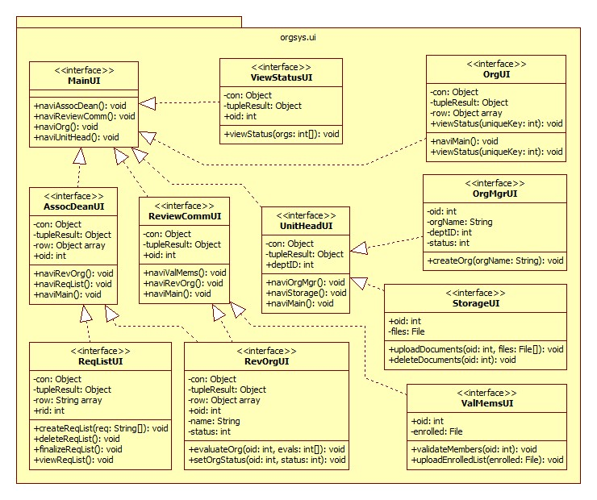

[Place here the class diagram of each package. Of course, the sample is not the class diagram of abl.athlete.con]

*List of Classes:*

| Class | Description |
| --- | --- |
| index.php | This is the main screen.  Methods:   * naviAssocDean(): void * naviReviewComm(): void * naviOrg(): void * naviUnitHead(): void |
| UnitHeadHome.php | This screen is the unit head’s main page.  Attributes:   * con: Object * tupleResult: Object * deptID: int   Methods:   * naviOrgMgr(): void * naviStorage(): void * naviMain(): void |
| OrgHome.php | Instances of this screen serve as the organizations’ home pages.  Attributes:   * con: Object * tupleResult: Object * row: Object array   Methods:   * naviMain(): void * viewStatus(uniqueKey: int): void |
| AssocDeanHome.php | This screen is the associate dean’s main page.  Attributes:   * con: Object * tupleResult: Object * row: Object array * oid: int   Methods:   * naviRevOrg(): void * naviReqList(): void * naviMain(): void |
| ReviewCommHome.php | Instances of this screen serve as the review committee’s home pages.  Attributes:   * con: Object * tupleResult: Object * oid: int   Methods:   * naviValMems(): void * naviRevOrg(): void * naviMain(): void |
| ViewStatusUI.php | This screen displays the recognition status of the organizations.  Attributes:   * con: Object * tupleResult: Object * oid: int   Methods:   * viewStatus(orgs: int[]): void |
| ReqListUI.php | This screen diplays the requirements checklist made by the associate dean.  Attributes:   * con: Object * tupleResult: Object * row: Object array * rid: int   Methods:   * createReqList(req: String[]): void * deleteReqList(): void * finalizeReqList(): void * viewReqList(): void |
| RevOrgUI.php | This screen is the navigation for the associate dean and the review committee to evaluate the organizations.  Attributes:   * con: Object * tupleResult: Object * row: Object array * oid: int * name: String * status: int   Methods:   * evaluateOrg(oid: int, evals: int[]): void * setOrgStatus(oid: int, status: int): void |
| ValMemsUI.php | This screen is the navigation for the review committee to check the validity of the members of the organizations.  Attributes:   * oid: int * enrolled: File   Methods:   * validateMembers(oid: int): void * uploadEnrolledList(enrolled: File): void |
| StorageUI.php | This screen is the navigation for the unit head to store the organizations’ documents.  Attributes:   * oid: int * files: File   Methods:   * uploadDocuments(oid: int, files: File[]): void * deleteDocuments(oid: int): void |
| OrgMgrUI.php | This screen is the navigation for the unit head to manage the organizations under his/her department.  Attributes:   * oid: int * orgName: String * deptID: int * status: int   Methods:   * createOrg(orgName: String): void |

*Package Name*: orgsys.pc

*Class Diagram*:

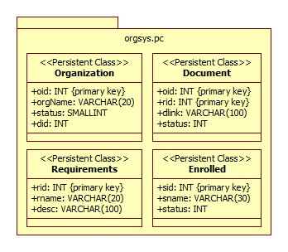

*List of Classes:*

| Class | Description |
| --- | --- |
| Organization.sql | Instance of the Organization persistent class. It contains all the organizations basic information for the system.  Attributes:   * oid: INT {primary key} * orgName: VARCHAR(20) * status: SMALLINT * did: INT |
| Document.sql | Instance of the Document persistent class. It contains information on the documents submitted by the organizations.  Attributes:   * oid: INT {primary key} * rid: INT {primary key} * dlink: VARCHAR(20) * status: INT |
| Requirements.sql | Instance of the Requirements persistent class. It is the requirements checklist made by the associate dean.  Attributes:   * rid: INT {primary key} * rname: VARCHAR(20) * desc: VARCHAR(100) |
| Enrolled.sql | Instance of the Enrolled persistent class. It is the record of the students enrolled in the university during the semester of the renewal process.  Attributes:   * sid: INT {primary key} * sname: VARCHAR(30) * status: INT |

*Package Name*: orgsys.db

*Class Diagram*:

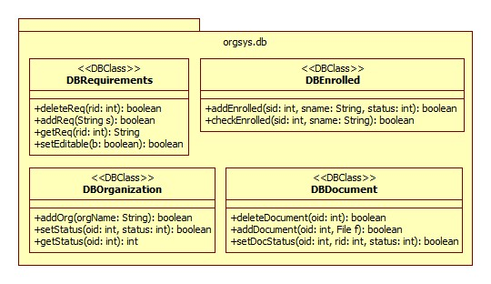

*List of Classes:*

| Class | Description |
| --- | --- |
| DBOrganization.php | DBClass that manipulates and accesses the Organization database.  Methods:   * addOrg(orgName: String): boolean * setStatus(oid: int, status: int): boolean * getStatus(oid: int): int |
| DBDocument.php | DBClass that manipulates and accesses the Document database.  Methods:   * deleteDocument(oid: int): boolean * addDocument(oid: int, f: File): boolean * setDocStatus(oid: int, rid: int, status: int): boolean |
| DBRequirements.php | DBClass that manipulates and accesses the Requirements database.  Methods:   * deleteReq(rid: int): boolean * addReq(s: String): boolean * getReq(rid: int): String * setEditable(b: boolean): boolean |
| DBEnrolled.php | DBClass that manipulates and accesses the Enrolled database.  Methods:   * addEnrolled(sid: int, sname: String, status: int): boolean * checkEnrolled(sid: int, sname: String): boolean |

*Package Name*: orgsys.ctrl

*Class Diagram*:

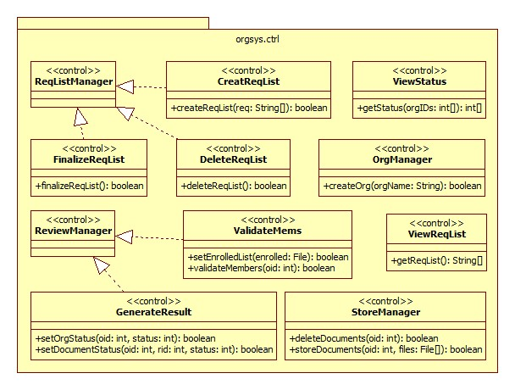

*List of Classes:*

| Class | Description |
| --- | --- |
| ReqListManager.php | This is control class for managing the requirements checklist.  Methods:   * NONE |
| CreateReqList.php | This is the control class for creating a requirements checklist.  Methods:   * createReqList(req: String[]): boolean |
| DeleteReqList.php | This is the control class for deleting a requirements checklist.  Methods:   * deleteReqList(): boolean |
| FinalizeReqList.php | This is the control class for finalizing the requirements checklist.  Methods:   * finalizeReqList(): boolean |
| ViewReqList.php | This is the control class for viewing the requirements checklist.  Methods:   * getReqList(): String[] |
| ReviewManager.php | This is the control class for managing the evaluation of the orgs by the associate dean and the review committee.  Methods:   * NONE |
| GenerateResult.php | This is the control class for getting the evaluation of the associate dean and the review committee on the organizations.  Methods:   * setOrgStatus(oid: int, status: int): boolean * setDocumentStatus(oid: int, rid: int, status: int): boolean |
| ValidateMems.php | This is the control class for checking the validity of enrollment of the members of the organizations.  Methods:   * setEnrolledList(enrolled: File): boolean * validateMembers(oid: int): boolean |
| ViewStatus.php | This is the control class for viewing the recognition status of organization/s.  Methods:   * getStatus(orgIDs: int[]): int[] |
| StorageManager.php | This is the control class that manages the documents stored in the online storage system.  Methods:   * deleteDocuments(oid: int): boolean * storeDocuments(oid: int, files: File[]): boolean |
| OrgManager.php | This is the control class for managing the organizations involved in the renewal process.  Methods:   * createOrg(orgName: String): boolean |